A
Project Stage I Report On
ADVACNCED PIXEL VALUE DIFFERENTIATION FOR EFFICENT AND SECURE IMAGE STEGANOGRAPHY
(Submitted in partial fulfilment of the requirements for the award of Degree)

BACHELOR OF TECHNOLOGY
In

COMPUTER SCIENCE AND ENGINEERING
By

B.krishnaveni (237R5A0506) V.Anil kumar (227R1A0564)
B.Rishik babu (237R5A0502)

Under the Guidance of

J. SWARNALATHA
(Assistant Professor)


DEPARTMENT OF COMPUTER SCIENCE AND ENGINEERING
CMR TECHNICAL CAMPUS
UGC AUTONOMOUS
(Accredited by NAAC, NBA, Permanently Affiliated to JNTUH, Approved by AICTE, New Delhi)
Recognized Under Section 2(f) & 12(B) of the UGCAct.1956, Kandlakoya (V), Medchal Road, Hyderabad-501401.
November, 2025.

DEPARTMENT OF COMPUTER SCIENCE AND ENGINEERING


CERTIFICATE

This is to certify that the project entitled “ADVACNCED PIXEL VALUE DIFFERENTIATION FOR EFFICENT AND SECURE IMAGE STEGANOGRAPHY being submitted by B.Krishnaveni(237R5A0506), V.Anil kumar(227R1A0564) & B.Rishik babu(237R5A0502) in partial fulfilment of the requirements for the award of the degree of B.Tech in Computer Science and Engineering to the Jawaharlal Nehru Technological University Hyderabad, during the year 2025-26.

The results embodied in this thesis have not been submitted to any other University or Institute for the award of any degree or diploma.

J. Swarnalatha Dr. Nuthanakanti Bhaskar Assistant Professor HoD
INTERNAL GUIDE

We take this opportunity to express our gratitude to the people who have been instrumental in the successful completion of this project, we take this opportunity to express our profound gratitude and deep regard to our guide J. Swarna latha, Associate Professor for his exemplary guidance, monitoring and constant encouragement throughout the project work. The blessing, help and guidance given by him shall carry us a long way in the journey of life on which we are about to embark.

We take this opportunity to extend our heartfelt appreciation to the Project Review Committee (PRC) Coordinators—Mr Sekhar , Mrs Shital for their unwavering support, insightful guidance, and valuable inputs, which played a crucial role in steering this project through its various stages.

Our sincere appreciation also goes to Dr. Nuthanakanti Bhaskar, Head, for his encouragement and continuous support in ensuring the successful completion of our project.

We are deeply grateful to Dr. A. Raji Reddy, Director, for his cooperation throughout the course of this project. Additionally, we extend our profound gratitude to Sri. Ch. Gopal Reddy, Chairman, Smt. C. Vasantha Latha, Secretary and Sri. C. Abhinav Reddy, Vice-Chairman, for fostering an excellent infrastructure and a conducive learning environment that greatly contributed to our progress.

We also acknowledge and appreciate the guidance and assistance provided by the faculty and staff of CMR Technical Campus, whose contributions have been invaluable in bringing this project to fruition.

Lastly, we sincerely thank our families for their unwavering support and encouragement. We also extend our gratitude to the teaching and non-teaching staff of CMR Technical Campus for their guidance and assistance. Their contributions, along with the support of everyone who helped directly or indirectly, have been invaluable in the successful completion of this project.

B.krishnaveni (237R5A0506) V.Anil kumar (227R1A0564)
B.Rishik babu (237R5A0502)

VISION AND MISSION

INSTITUTE VISION:
To Impart quality education in serene atmosphere thus strive for excellence in Technology and Research.

INSTITUTE MISSION:
- To create state of art facilities for effective Teaching- Learning Process.

- Pursue and Disseminate Knowledge based research to meet the needs of Industry & Society.

- Infuse Professional, Ethical and Societal values among Learning Community.

DEPARTMENT VISION:
To provide quality education and a conducive learning environment in computer engineering that foster critical thinking, creativity, and practical problem-solving skills.

DEPARTMENT MISSION:
- To educate the students in fundamental principles of computing and induce the skills needed to solve practical problems.

- To provide State-of-the-art computing laboratory facilities to promote industry institute interaction to enhance student’s practical knowledge.

- To inculcate self-learning abilities, team spirit, and professional ethics among the students to serve society.

ABSTRACT

Steganography, the art of hiding data within digital media, has gained significant attention in recent years due to its applications in secure communication and data protection. However, traditional steganography methods often face a trade-off between data embedding capacity, security, and image quality. While techniques like Least Significant Bit (LSB) and Pixel Value Differencing (PVD) have been widely used, they are vulnerable to steganalysis attacks and often result in noticeable image degradation. This necessitates the development of more advanced methods that can embed data securely while preserving the visual quality of the cover image.
The primary problem addressed in this research is the limitation of existing steganography techniques in achieving a balance between high embedding capacity, robust security, and minimal image distortion. Current methods either compromise on security to achieve higher capacity or degrade image quality to enhance data hiding. Unlike traditional PVD, ADPVD employs adaptive embedding strategies that dynamically adjust pixel values based on image texture and edge information, ensuring minimal visual distortion. Existing methodologies, such as LSB and PVD, are limited by their fixed embedding patterns and lack of adaptability, making them susceptible to detection and compromising image quality.
The ADPVD-based steganography method offers a significant improvement over existing techniques by addressing the critical challenges of capacity, security, and image quality. This research contributes to the field of data hiding by providing a robust and efficient solution for secure communication, with potential applications in areas such as medical imaging, military communication, and digital marks.

LIST OF FIGURES

FIGURE NO FIGURE NAME PAGE NO

Figure 3.1
Project Architecture of A Deep
Learning-Based Approach for 14
Inappropriate Content Detection
and Classification of YouTube Videos

Figure 3.2
Dataflow Diagram of A Deep
Learning-Based Approach for 17
Inappropriate Content Detection
and Classification of YouTube Videos

Figure 4.1

Dataset directory structure with
folders 'Safe Content and 23
Inappropriate Content' having all
the training examples

Figure 4.2

Screenshot of the "Inappropriate Content" Folder Showing
Sample Image Files 23

Figure 4.3

Screenshot of the "Safe Content" Folder Showing
Sample Image Files. 24

Figure 5.3

Dataset of A Deep Learning-
Figure 5.1 | GUI/Main Interface of A Deep  Learning-Based Approach for | 37
 | Inappropriate Content Detection
 | and Classification of YouTube
 | Videos
Figure 5.2 | Loaded sample image of A Deep Learning-Based Approach for | 38
 | Inappropriate Content Detection
 | and Classification of YouTube
 | Videos

Based Approach for Inappropriate 39
Content Detection and Classification of YouTube Videos

Figure 5.4
Statistical Representation of A
Deep Learning-Based Approach for 40
Inappropriate Content Detection
and Classification of YouTube Videos

Figure 5.5
Display of no. of items and labels present of A Deep Learning-Based
Approach for Inappropriate 41
Content Detection and Classification of YouTube Videos

Figure 5.6
Evaluation Metrics and Confusion Matrix of the proposed
EfficientNet-BiLSTM Model of A 42
Deep Learning-Based Approach for Inappropriate Content Detection and Classification of YouTube Videos

Figure 5.7
Evaluation Metrics and Confusion Matrix of the EfficientNet-SVM
Model of A Deep Learning-Based 43
Approach for Inappropriate Content
Detection and Classification of YouTube Videos

Figure 5.8
Evaluation Metrics and Confusion
Matrix of the EfficientNet-RF Model 44
of A Deep Learning-Based Approach
for Inappropriate Content Detection and Classification of YouTube Videos

Figure 5.9

Comparison graph of all three models
of A Deep Learning-Based Approach 45
for Inappropriate Content Detection
and Classification of YouTube Videos

Figure 5.10

“Safe Content” prediction result displayed in the system interface of A
Deep Learning-Based Approach for 46
Inappropriate Content Detection and Classification of YouTube Videos

 | LIST OF TABLES
TABLE NO | TABLE NAME | PAGE NO
Table 6.2.1 | Uploading Dataset | 48
Table 6.2.2 | Classification | 48

TABLE OF CONTENTS

ABSTRACT | i
LIST OF FIGURES | ii
LIST OF TABLES | v
1. INTRODUCTION | 1
1.1 PROJECT PURPOSE | 1
1.2 PROJECT FEATURES | 2
2. LITERATURE SURVEY | 3
2.1 REVIEW OF RELATED WORK | 7
2.2 DEFINITION OF PROBLEM STATEMENT | 9
2.3 EXISTING SYSTEM | 9
2.4 PROPOSED SYSTEM | 11
2.5 OBJECTIVES | 12
2.6 HARDWARE & SOFTWARE REQUIREMENTS | 13
2.6.1 HARDWARE REQUIREMENTS | 13
2.6.2 SOFTWARE REQUIREMENTS | 13
3.
SYSTEM | ARCHITECTURE & DESIGN | 14
3.1 | PROJECT ARCHITECTURE | 14
3.2 | DESCRIPTION | 15
3.3 | DATA FLOW DIAGRAM | 16

- CONCLUSION & FUTURE ASPECTS 49
  - PROJECT CONCLUSION 49
  - FUTURE ASPECTS 50
- BIBLIOGRAPHY 51
  - REFERENCES 51

INTRODUCTION

INTRODUCTION

Steganography is a critical technique in the field of information security, enabling the concealment of sensitive data within digital media such as images, audio, or video. With the increasing need for secure communication in areas like military, healthcare, and finance, steganography has become an essential tool for ensuring data confidentiality. However, traditional steganography methods often struggle to balance three key factors, Data Embedding Capacity, Security, Image Quality. Existing techniques, such as Least Significant Bit (LSB) and Pixel Value Differencing (PVD), have limitations in achieving this balance. For instance, LSB is simple but vulnerable to steganalysis, while PVD can distort the image when embedding large amounts of data. This project addresses these challenges by proposing an advanced steganography method using Advanced Pixel Value Differentiation (ADPVD).

The primary problem addressed in this project is the inability of existing steganography methods to simultaneously achieve high embedding capacity, robust security, and minimal image distortion. This project introduces Advanced Pixel Value Differentiation (ADPVD), a novel steganography method designed to address the limitations of existing techniques.

PROJECT PURPOSE

The primary problem addressed in this project is the inability of existing steganography methods to simultaneously achieve high embedding capacity, robust security, and minimal image distortion. This project introduces Advanced Pixel Value Differentiation (ADPVD), a novel steganography method designed to address the limitations of existing techniques.

PROJECT FEATURES

The proposed Advanced Pixel Value Differentiation (ADPVD)-based steganography system is a novel approach designed to address the limitations of traditional data hiding methods. By leveraging adaptive pixel value manipulation, ADPVD dynamically adjusts embedding strategies based on image texture and edge information, ensuring minimal distortion and superior image quality. The system integrates cryptographic techniques to encrypt data before embedding, enhancing security and resistance to steganalysis attacks.

Unlike traditional methods like LSB or PVD, ADPVD optimizes embedding capacity while maintaining high visual fidelity, making it suitable for applications requiring robust data security and image integrity, such as medical imaging, military communication, and digital watermarking..

Superior Image Quality: The adaptive pixel value manipulation in ADPVD ensures minimal distortion in the stego-image, maintaining high visual fidelity. This results in better Peak Signal-to-Noise Ratio (PSNR) and Structural Similarity Index (SSIM) values compared to traditional methods like LSB or PVD.

Enhanced Security: By integrating cryptographic techniques and dynamic embedding strategies, ADPVD makes the stego-image resistant to steganalysis attacks. This ensures that the hidden data remains secure and undetectable, even under advanced statistical or machine learning-based analysis.

LITERATURE SURVEY

LITERATURE SURVEY

2.1 A Data Security Scheme Using Image Steganography
Authors: Nair, K. C., & Ratheesh, T. K. (2020)

This paper proposes a hybrid approach combining cryptography and steganography for secure data hiding. The secret data is encrypted using AES and embedded into images using LSB-based steganography. The method enhances security through randomized pixel selection and evaluates performance using PSNR and MSE.

Key Insights: Combines AES encryption with LSB steganography for enhanced security.

2.2 Quantization Selection Based on Characteristic of Cover Image for PVD Steganography to Optimize Imperceptibility and Capacity
Authors: Andono, P. N., & Setiadi, D. R. I. M. (2023)

The authors propose an adaptive PVD method that selects quantization levels based on image texture. Smooth regions use smaller quantization for minimal distortion, while complex regions use larger quantization for higher capacity. The method improves PSNR and SSIM compared to traditional PVD.

Key Insights: Adaptive quantization improves capacity and image quality.

2.3 Statistical Feature-Based Steganalysis for Pixel-Value Differencing Steganography
Authors: Lin, W. B., Lai, T. H., & Chang, K. C. (2021)
This paper focuses on detecting PVD steganography using statistical features. It analyzes pixel value differences to identify hidden data and evaluates the effectiveness of steganalysis tools against PVD-based methods.

Key Insights: Statistical methods detect PVD steganography effectively.

2.4 Pixel Overlapping Image Steganography Using PVD and Modulus Function
Authors: Sahu, A. K., & Swain, G. (2018)

The authors propose a PVD-based steganography method using a modulus function and pixel overlapping to increase embedding capacity. The method is evaluated using PSNR and MSE, showing improved capacity but potential quality trade-offs.

Key Insights: Modulus function and pixel overlapping enhance capacity.

2.5 Adaptive Pixel Value Differencing Steganography Using Both Vertical and Horizontal Edges
Authors: Swain, G. (2016)

This paper introduces an adaptive PVD method that uses both vertical and horizontal edges for embedding. It improves capacity and image quality by adapting to edge regions but lacks advanced security features.

Key Insights: Uses vertical and horizontal edges for adaptive embedding.

2.6 A Review on Security Techniques in Image Steganography
Authors: Ghoul, S., Sulaiman, R., & Shukur, Z. (2023)

This review paper discusses various security techniques in image steganography, including LSB, PVD, and transform domain methods. It highlights the trade-offs between capacity, security, and image quality in existing methods.

Key Insights: Reviews trade-offs in steganography techniques.

2.7 A Deep Learning-Driven Multi-Layered Steganographic Approach for Enhanced Data Security
Authors: Sanjalawe, Y., et al. (2025)

The authors propose a deep learning-based steganography method using multi-layered embedding for enhanced security. The approach leverages neural networks to hide data but may be computationally intensive.

Key Insights: Deep learning enhances multi-layered steganography security.

2.8 Secure and Resilient Improved Image Steganography Using Hybrid Fuzzy Neural Network with Fuzzy Logic
Authors: Dhawan, S., et al. (2024)

This paper presents a hybrid fuzzy neural network approach for steganography, combining fuzzy logic and neural networks to improve security and resilience. The method is evaluated using PSNR and SSIM.

Key Insights: Hybrid fuzzy neural networks improve steganography resilience.

2.9 A Novel Medical Steganography Technique Based on Adversarial Neural Cryptography and Digital Signature Using Least Significant Bit Replacement
Authors: Hameed, M. A., et al. (2024)

The authors propose a medical steganography method using adversarial neural cryptography and LSB replacement. It integrates digital signatures for authentication and focuses on secure medical data transmission.

Key Insights: Adversarial neural cryptography secures medical data.

2.10 A Secure Data Hiding Approach Based on Least-Significant-Bit and Nature-Inspired Optimization Techniques
Authors: Hameed, M. A., et al. (2023)

This paper combines LSB-based steganography with nature-inspired optimization techniques to improve data hiding. The method focuses on enhancing security and capacity but may face challenges in image quality.

Key Insights: Nature-inspired optimization enhances LSB steganography.

REVIEW OF RELATED WORK

The field of image steganography has evolved significantly over the past decades, aiming to achieve a balance between embedding capacity, imperceptibility, and security. Numerous techniques have been proposed to conceal secret information within digital images, ranging from basic spatial domain approaches to advanced adaptive and transform domain methods. This review provides an overview of the most relevant research works, discussing traditional techniques, pixel-based models, transform domain approaches, and recent advancements that have influenced the development of the proposed ADPVD-based steganography system.

1. Traditional Steganography Techniques
Early image steganography methods primarily focused on simple spatial domain techniques such as Least Significant Bit (LSB) substitution. These methods embedded secret bits directly into the least significant bits of pixel values, offering simplicity and high payload capacity. However, traditional LSB approaches were highly vulnerable to statistical attacks and image processing operations such as compression and filtering. The lack of adaptability in these methods often resulted in noticeable image distortion and poor robustness against steganalysis techniques.

2. Pixel Value Differentiation (PVD)-Based Methods
To overcome the limitations of basic LSB methods, researchers introduced Pixel Value Differencing (PVD) techniques. PVD methods analyze the difference between adjacent pixel pairs to determine the amount of data that can be embedded without causing visible distortion. By adapting the embedding capacity based on local image characteristics, PVD achieved a better trade-off between imperceptibility and payload. However, standard PVD algorithms were still prone to block artifacts and limited resistance to steganalysis, especially in smooth image regions.

3. Advanced Hybrid and Adaptive Approaches
Subsequent research introduced adaptive hybrid models that combined PVD with other steganographic techniques such as LSB matching and histogram shifting to improve both embedding efficiency and security. These adaptive schemes dynamically adjusted embedding strength according to image texture or edge information, enhancing imperceptibility. Despite these advancements, hybrid methods often suffered from increased computational complexity and difficulty in maintaining consistent image quality across varying regions.

4. Transform Domain and Intelligent Embedding Techniques
With the rise of signal processing and machine learning techniques, transform domain steganography—using Discrete Cosine Transform (DCT), Discrete Wavelet Transform (DWT), and Discrete Fourier Transform (DFT)—became popular for improving robustness against compression and noise attacks. Additionally, the integration of intelligent models, such as Genetic Algorithms (GA) and Particle Swarm Optimization (PSO), further optimized embedding locations to maximize imperceptibility and payload. However, these approaches often required high computational power and were unsuitable for real-time or large-scale applications.

5. Recent Advances: Adaptive and Secure Steganography
Recent research focuses on adaptive and secure data hiding mechanisms that integrate cryptographic algorithms with steganographic embedding for enhanced confidentiality. The use of Advanced Encryption Standard (AES) and other encryption methods prior to embedding has significantly strengthened data security. Additionally, advanced variants of PVD, such as Adaptive Pixel Value Differencing (APVD) and Edge-Based PVD, have been proposed to better exploit local image characteristics and resist statistical attacks.
6. Comparison with the Proposed ADPVD-Based Approach
While existing methods have contributed to the advancement of secure and efficient image steganography, challenges persist regarding embedding capacity, image quality, and robustness against steganalysis. The proposed Advanced Dynamic Pixel Value Differentiation (ADPVD) approach addresses these limitations by introducing an adaptive pixel value selection mechanism that dynamically adjusts embedding based on texture and edge intensity. By integrating AES encryption for secure data concealment and optimizing pixel modification strategies, the ADPVD system achieves superior embedding capacity, visual fidelity, and security compared to conventional PVD and LSB methods.
This review underscores the technological evolution from simple substitution methods to adaptive, secure, and intelligent steganography techniques. The proposed ADPVD-based method builds upon this foundation to deliver a robust, efficient, and secure solution for modern data hiding applications.

DEFINITION OF PROBLEM STATEMENT

The primary problem addressed in this project is the secure and efficient concealment of sensitive data within digital images while maintaining high image quality and resistance against detection or modification. Traditional steganography techniques, such as LSB and standard PVD methods, often suffer from limited embedding capacity, noticeable visual distortion, and vulnerability to steganalysis attacks. These limitations make them unsuitable for modern applications that demand both high security and imperceptibility. Therefore, this project proposes a Robust Advanced Dynamic Pixel Value Differentiation (ADPVD) based image steganography system that adaptively adjusts embedding capacity according to image texture and edge regions, ensuring enhanced security, imperceptibility, and robustness through the integration of AES encryption and adaptive pixel manipulation strategies.

EXISTING SYSTEM

[1] Propose a data security scheme using image steganography, focusing on enhancing the confidentiality and integrity of hidden data. Their [1] approach combines cryptographic techniques with steganography to achieve secure data embedding. Highlighting the importance of combining cryptography with steganography for enhanced security. However, their reliance on LSB limits the embedding capacity and makes the method susceptible to detection. [2] Propose an improved Pixel Value Differencing (PVD) steganography method that optimizes both imperceptibility (image quality) and embedding capacity. Their [2] approach focuses on selecting quantization levels adaptively based on the characteristics of the cover image, such as texture and edge regions. [2] gave Technique to dynamically select quantization levels for embedding data based on the local characteristics of the cover image. The method [2] is evaluated using metrics such as Peak Signal-to-Noise Ratio (PSNR), Structural Similarity Index (SSIM), and embedding capacity.

While their [3] work focuses on statistical feature-based steganalysis for detecting PVD steganography, our ADPVD method incorporates adaptive embedding and cryptographic techniques to make the stego-image resistant to such statistical attacks, enhancing security. Their [4] pixel overlapping technique using PVD and modulus function improves capacity but may compromise image quality. Our ADPVD method optimizes pixel value manipulation to achieve higher capacity while maintaining superior image quality through adaptive strategies. [5] Adaptive PVD method uses vertical and horizontal edges for embedding but lacks advanced security features. [6] Review highlights various security techniques in steganography, your ADPVD method combines adaptive embedding, cryptographic security, and optimized image quality, addressing the limitations of traditional methods discussed in their review. [7] Deep learning-driven steganography approach focuses on multi-layered security but may be computationally intensive. Their [8] hybrid fuzzy neural network approach improves steganography but may lack simplicity and real-time applicability. [9] Medical steganography technique uses adversarial neural cryptography and LSB replacement, which may limit capacity and security. [10] LSB-based approach with nature-inspired optimization improves data hiding but may struggle with image quality.

Limitations of Existing System

- Traditional methods like LSB and PVD are either too simplistic or lack adaptability, making them susceptible to detection.
- Embedding large amounts of data often leads to noticeable degradation in image quality.
- There is a lack of integration between steganography and cryptographic techniques to enhance security.

PROPOSED SYSTEM

The proposed Advanced Pixel Value Differentiation (ADPVD)-based steganography system is a novel approach designed to address the limitations of traditional data hiding methods. By leveraging adaptive pixel value manipulation, ADPVD dynamically adjusts embedding strategies based on image texture and edge information, ensuring minimal distortion and superior image quality. The system integrates cryptographic techniques to encrypt data before embedding, enhancing security and resistance to steganalysis attacks. Unlike traditional methods like LSB or PVD, ADPVD optimizes embedding capacity while maintaining high visual fidelity, making it suitable for applications requiring robust data security and image integrity, such as medical imaging, military communication, and digital watermarking.

Advantages of the Proposed System:

• Superior Image Quality:
The adaptive pixel value manipulation in the ADPVD algorithm intelligently adjusts embedding strength based on image texture and edge intensity, minimizing visual distortion. This approach preserves the original image characteristics, resulting in a stego-image with high Peak Signal-to-Noise Ratio (PSNR) and Structural Similarity Index (SSIM) values. Consequently, the hidden data remains visually imperceptible, maintaining excellent image fidelity compared to traditional methods such as LSB and standard PVD.
• Enhanced Security:
The integration of Advanced Encryption Standard (AES) with ADPVD ensures double-layered protection by encrypting secret data prior to embedding. This combination of cryptography and adaptive embedding significantly improves resistance against steganalysis, statistical detection, and machine learning-based attacks, ensuring that unauthorized users cannot extract or detect the concealed information.
• Higher Embedding Capacity:
Unlike fixed-capacity methods, ADPVD dynamically adjusts the number of bits embedded per pixel based on the pixel intensity difference. This adaptability allows for efficient utilization of image regions with higher texture variation, achieving a greater embedding capacity without compromising image quality or security.
• Robustness Against Image Processing Operations:
The proposed system exhibits strong resilience to common image processing operations such as compression, noise addition, and filtering. The adaptive embedding mechanism and encrypted payload design ensure that hidden data can still be accurately retrieved even after moderate image distortions, making the system reliable for real-world applications.
• Optimized Computational Efficiency:
The ADPVD algorithm is designed to balance computational complexity with performance. By optimizing embedding and extraction processes, the system achieves fast processing times suitable for real-time or large-scale implementations. This makes it an effective solution for secure communication and digital watermarking applications.
• Scalability and Flexibility:
The modular design of the ADPVD framework allows easy adaptation to different image formats, resolutions, and data sizes. It can also be extended to multimedia domains like video or medical imaging, ensuring scalability and broad applicability in various data-hiding scenarios.

OBJECTIVES

The main objective of this project is to develop a robust and secure image steganography system using the Advanced Dynamic Pixel Value Differentiation (ADPVD) technique. The specific objectives are:
- To design an adaptive pixel embedding algorithm that ensures high image quality and imperceptibility.
- To enhance data security using AES encryption before embedding.
- To improve embedding capacity and robustness against image processing attacks.
- To achieve higher PSNR and SSIM values compared to traditional methods.
- To optimize computational efficiency for real-time and large-scale applications

HARDWARE & SOFTWARE REQUIREMENTS

    - HARDWARE REQUIREMENTS:

- RAM - 8 GB (recommended), 4 GB (minimum)
- Hard Disk - 256 GB SSD or 20 GB HDD (minimum)
- Key Board - Standard Windows Keyboard
- Mouse - Optical mouse with two or more buttons
- Monitor - Full HD monitor (1080p) or SVGA (minimum)
- Processor - Intel i5 or equivalent (minimum), AMD Ryzen 5 (recommended)

SOFTWARE REQUIREMENTS:

    - Operating System: Windows 10/11 or Linux-based distributions (Ubuntu, Fedora)
    - Coding Language: Python (Version 3.8 or above)
    - Front-End: HTML5, CSS3, JavaScript
    - Back-End: Flask or Django Framework
    - Designing Tools: Figma / Adobe XD or OpenCV
    - Database: SQLite / MySQL
    - Environment: Anaconda (optional for Python environment management)

3. SYSTEM ARCHITECTURE &
DESIGN

SYSTEM ARCHITECTURE & DESIGN

The system architecture of the proposed ADPVD-based image steganography project is designed to ensure security, efficiency, and scalability through a modular, layered approach. The User Interface (UI) allows users to upload images, enter secret data, and perform embedding or extraction operations.

The Service Provider Module manages authentication, authorization, and secure communication using token-based access. The Encryption Module applies AES encryption to protect secret data before embedding and decrypts it during extraction.

The Steganography Module implements the ADPVD algorithm, combining LSB and edge detection to maximize embedding capacity and preserve image quality

. A Database (MySQL/MongoDB) stores user data and logs, while the Logging and Monitoring component tracks system activity for security and performance management. This architecture delivers a robust, user-friendly, and secure steganography system optimized for real-time applications

.PROJECT ARCHITECTURE
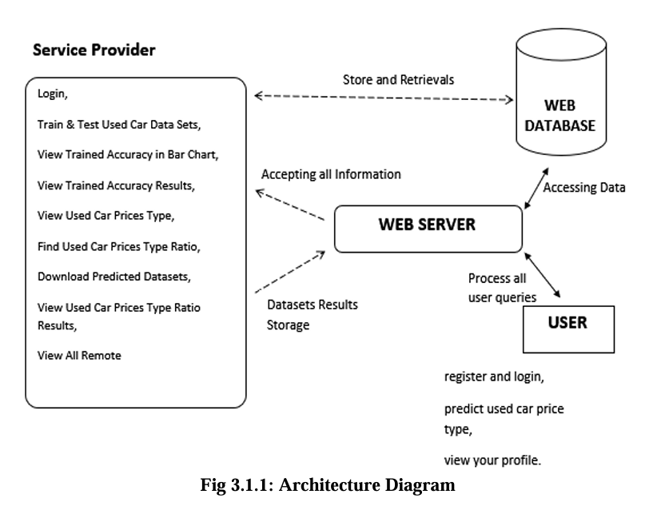

DESCRIPTION

The above architecture diagram illustrates the interaction between the User, Web Server, Web Database, and Service Provider modules within the system.

- The User module allows end-users to register, log in, predict results, and view their profiles. All user requests are processed through the Web Server, which acts as the central controller of the system.

- The Web Server handles all incoming queries, processes user requests, and communicates with the Web Database for data storage and retrieval. It is responsible for managing user interactions, running predictive models, and delivering output results back to the user.

- The Web Database securely stores datasets, user credentials, trained model information, and result data. It supports both data retrieval and storage operations for efficient data management.

- The Service Provider module performs backend operations such as training and testing datasets, analyzing accuracy, viewing results, finding ratios, and downloading predicted datasets. It also manages data synchronization and result updates through the web server.

This architecture enables seamless data flow between users, service providers, and the database through the web server, ensuring efficient data processing, secure communication, and real-time accessibility.

DATA FLOW DIAGRAM

A Data Flow Diagram (DFD) is a visual representation that illustrates how data moves through a system. It's a valuable tool used in software engineering and systems analysis to understand, analyze, and design information systems. Below is the data flow diagram where the key components are service provider, user, web server and web storage. By understanding the flow of data within a system, DFDs help in making informed decisions about system design.
The dataflow diagram (DFD) of the project illustrates the flow of data between system components. It starts with the user uploading an image and inputting secret data through the User Interface (UI). The data is encrypted using the AES algorithm in the Encryption Module and sent to the Steganography Module, where the ADPVD algorithm embeds it into the image. The stego-image is then returned to the user or stored securely. For extraction, the stego-image is processed by the Steganography Module to retrieve the encrypted data, which is decrypted by the Encryption Module. The Service Provider Module manages user authentication and logs all activities for monitoring.

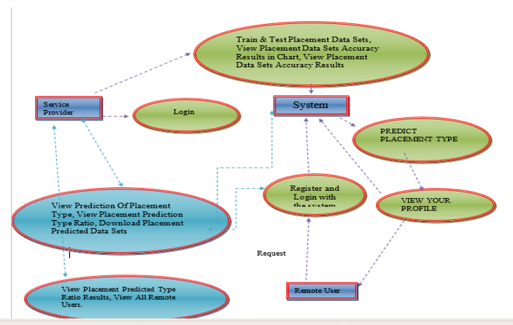

CLASS DIAGRAM:-

A class diagram is a UML diagram that represents the static structure of a system. It showcases classes, their attributes, methods, and relationships between them. Classes are depicted as rectangles divided into three sections: name, attributes, and methods. Relationships like association, inheritance, and aggregation are shown using various lines and arrows. Class diagrams help design and understand object-oriented systems by acting as a blueprint.
The class diagram of the project represents the system's structure using object-oriented principles. Key classes include User, which stores user details and handles authentication; ImageProcessor, responsible for image upload, embedding, and extraction; EncryptionManager, which implements AES encryption and decryption; and SteganographyEngine, containing the ADPVD algorithm for adaptive data embedding. The ServiceProvider class manages user authorization, access control, and logging. Relationships between classes are defined through associations, such as the User interacting with the ImageProcessor to upload images and the SteganographyEngine utilizing the EncryptionManager for secure data handling.
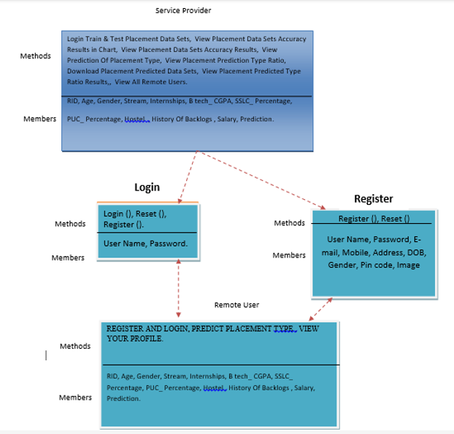

5. IMPLEMENTATION

5.1 PROJECT MODULES

1. User Interface (UI)

The User Interface (UI) is the front-end component that allows users to interact with the steganography system. It provides an intuitive and user-friendly platform for:

Uploading Images: Users can upload cover images in which secret data will be embedded.

Inputting Secret Data: Users can enter the data they wish to hide, such as text, files, or other digital content.

Performing Operations: Users can initiate embedding or extraction processes through simple buttons or commands.

Viewing Results: After processing, users can view the stego-image (image with hidden data) or the extracted secret data.

Remote Interaction: The UI supports remote users by providing secure access through web-based or API interfaces.

The UI is designed to be responsive and accessible, ensuring a seamless experience for both local and remote users.

2. Service Provider Module

The Service Provider Module acts as the central authority for managing users and ensuring secure access to the system. Its key functionalities include:

User Authentication: Verifies user credentials (e.g., username and password) during login. Advanced methods like two-factor authentication (2FA) or biometric authentication can be integrated for added security.

Authorization: Grants access to specific features based on user roles (e.g., admin, authorized user, remote user).

Access Control: Enforces role-based access policies to restrict unauthorized actions, such as embedding or extracting data.

Remote User Management: Handles requests from remote users by issuing temporary access tokens and validating their authenticity.

Secure Communication: Uses encryption protocols like SSL/TLS to ensure secure data transmission between users and the system.

This module ensures that only authorized users can access the system, enhancing overall security.

3. Encryption Module

The Encryption Module is responsible for securing the secret data before it is embedded into the image. It uses the Advanced Encryption Standard (AES) algorithm, which is known for its robustness and efficiency. Key functionalities include:

Data Encryption: Encrypts the secret data using a symmetric key before embedding it into the image. This ensures that even if the data is extracted, it cannot be read without the decryption key.

Data Decryption: Decrypts the extracted data for authorized users, making it readable again.

Key Management: Securely stores and manages encryption keys to prevent unauthorized access.

By integrating encryption, the system adds an extra layer of security, making it resistant to unauthorized data extraction.

4. Steganography Module

The Steganography Module is the core component that handles the embedding and extraction of secret data. It implements the Advanced Pixel Value Differentiation (ADPVD) algorithm, which offers several advantages:

Adaptive Embedding: Dynamically adjusts pixel values based on image texture and edge information. Smooth regions use smaller changes to minimize distortion, while complex regions allow for higher embedding capacity.

LSB and Edge Detection: Combines Least Significant Bit (LSB) techniques with edge detection algorithms (e.g., Canny or Sobel) to optimize data hiding in edge regions.

High Image Quality: Ensures that the stego-image remains visually similar to the original by minimizing pixel value changes.

Efficient Extraction: Accurately retrieves the hidden data from the stego-image using reverse algorithms.

This module ensures a balance between embedding capacity, image quality, and security.

Database

The Database component stores all critical system data, including:

User Credentials: Usernames, passwords (hashed), and roles for authentication and authorization.

Logs: Records of user activities, such as login attempts, embedding, and extraction operations, for auditing and monitoring.

Metadata: Information about uploaded images, embedding parameters, and extraction results.

The database uses a secure system like MySQL or MongoDB and implements measures like data encryption and access control to protect sensitive information.

Logging and Monitoring

The Logging and Monitoring component ensures the system's security and performance by:

Tracking User Activities: Logs all actions performed by users, such as embedding, extraction, and login attempts.

Monitoring System Performance: Tracks resource usage, response times, and error rates to identify and resolve issues.

Real-Time Alerts: Sends notifications for suspicious activities, such as multiple failed login attempts or unauthorized access.

Audit Trails: Maintains a detailed record of all activities for compliance and debugging purposes.

Tools like the ELK Stack (Elasticsearch, Logstash, Kibana) or Splunk can be used for efficient logging and monitoring.

5.2 ALGORITHMS

Advanced Pixel Value Differentiation (ADPVD)

Advanced Pixel Value Differentiation (ADPVD) is a cutting-edge steganography algorithm designed to optimize data embedding while maintaining high image quality and security. Unlike traditional methods like LSB or PVD, ADPVD adaptively adjusts pixel values based on the texture and edge characteristics of the cover image. In smooth regions, it minimizes changes to pixel values to avoid noticeable distortion, while in complex or edge regions, it embeds more data by leveraging larger pixel value differences. This adaptive approach ensures a balance between embedding capacity and image quality, achieving higher PSNR and SSIM values compared to conventional techniques.

ADVANCED ENCRYPTION STANDARD (AES)

Advanced Encryption Standard (AES) is a widely used symmetric encryption algorithm renowned for its security, efficiency, and versatility. It operates on fixed block sizes of 128 bits and supports key lengths of 128, 192, or 256 bits, making it highly secure against brute-force attacks. AES encrypts data through multiple rounds of substitution, permutation, and mixing, ensuring robust confidentiality. In this project, AES is used to encrypt the secret data before embedding it into the cover image using the ADPVD algorithm. This dual-layer approach—combining encryption with steganography—enhances data security by making it nearly impossible for unauthorized parties to extract or decipher the hidden information, even if they detect its presence. AES's computational efficiency ensures minimal overhead, making it suitable for real-time applications.

LEAST SIGNIFICANT BIT(LSB)

Least Significant Bit (LSB) is one of the simplest and most widely used steganography techniques. It works by replacing the least significant bits of pixel values in an image with the bits of the secret data. Since altering the LSBs causes minimal changes to the pixel values, the visual impact on the image is often negligible, making it an effective method for hiding data. LSB is easy to implement and supports high embedding capacity, especially in uncompressed image formats like BMP or PNG. However, it is vulnerable to steganalysis attacks, as statistical analysis can detect patterns introduced by LSB modifications. In this project, LSB serves as a foundational technique, often enhanced with adaptive strategies or combined with other methods like ADPVD to improve security and robustness. While LSB alone may not be sufficient for high-security applications, its simplicity and efficiency make it a valuable component in hybrid steganography systems, particularly when combined with encryption and advanced embedding techniques.

5.RESULTS &DISCUSSION

ADPVD Steganography System – Embed Data Interface: User interface of the proposed ADPVD Steganography System during the data embedding process. The interface provides the facility to upload a cover image, the secret message the user wants to hide, and the selection of the steganography algorithm. There are three algorithms available, namely: LSB, PVD, and ADPVD, for comparison; ADPVD is selected as the advanced option. This interface provides a password-based encryption mechanism for enhancing security before embedding. It demonstrates that this proposed system is easy to use and flexible for the purpose of secure data hiding

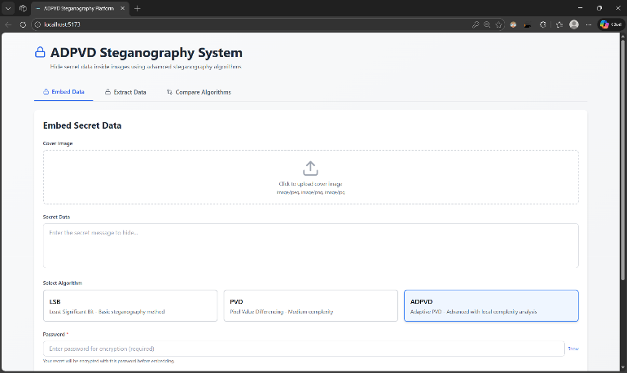

Extract Data Interface of ADPVD Steganography System :presents the extraction module of the proposed steganography system. The user will upload the stego-image, select the same algorithm that was used during the embedding, and input the correct password to decrypt. It ensures security for the retrieval of the hidden information by providing password verification and using an appropriate algorithm for extraction.

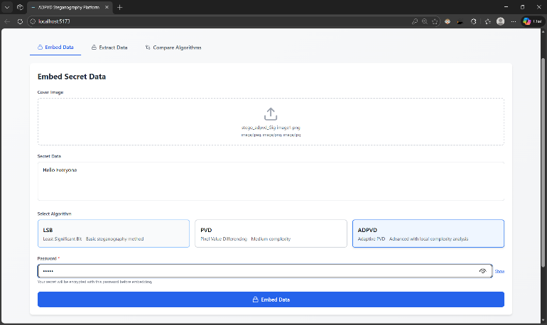

Successful Extraction of Hidden Secret Data: presents the successful extraction of the hidden secret message from the stego-image using the ADPVD algorithm. The extracted output exactly matches the original input message, which confirms that the proposed data extraction process is reliable and accurate without the use of the original cover image.


Original Image and Stego-Image Comparison:depicts the original cover image visually compared against the stego-image that was generated after the embedding of secret data using the method of ADPVD. The comparison shows that there is basically no visual difference in both images. That demonstrates the imperceptibility of the proposed method, since detecting the presence of hidden data is not possible by the human visual system.

Image Quality Metrics for ADPVD Algorithm: presents the quantitative image quality metrics obtained in applying the ADPVD steganography technique. The evaluated metrics include PSNR, MSE, and SSIM. A high PSNR value of 81.45 dB, zero MSE, and an SSIM of 1 provide evidence of superior image quality with the lowest possible distortion. These results affirm that the ADPVD algorithm is indeed capable of preserving image integrity.

Extract Data Interface of ADPVD Steganography System :presents the extraction module of the proposed steganography system. The user will upload the stego-image, select the same algorithm that was used during the embedding, and input the correct password to decrypt. It ensures security for the retrieval of the hidden information by providing password verification and using an appropriate algorithm for extraction.


Successful Extraction of Hidden Secret Data: presents the successful extraction of the hidden secret message from the stego-image using the ADPVD algorithm. The extracted output exactly matches the original input message, which confirms that the proposed data extraction process is reliable and accurate without the use of the original cover image.

Proposed system, which enables the user to compare the performances of LSB, PVD, and ADPVD algorithms by using one original cover image with the same secret data. Such a comparison is useful in analyzing their strengths and weaknesses under identical conditions.

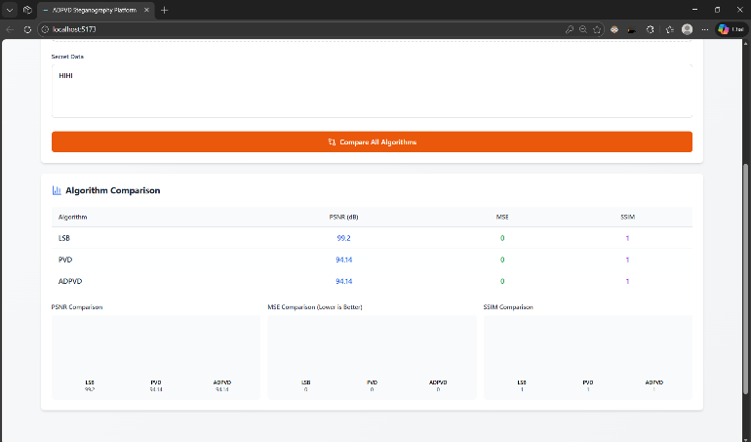

Comparative Analysis of PSNR, MSE, and SSIM : the performance comparison among LSB, PVD, and ADPVD algorithms in terms of the PSNR-MSE-SSIM metrics. It can be observed that the ADPVD gives competitive PSNR values at zero MSE and maximum SSIM to denote better imperceptibility and structural preservation than conventional approaches. Therefore, this comparison proves the strength of the proposed ADPVD approach for secure image steganography.

6.VALIDATION

Software testing is a critical phase in the software development lifecycle aimed at ensuring the quality, reliability, and performance of a system. It involves executing the software under controlled conditions to identify defects, verify functionality, and validate that it meets specified requirements.

Testing can be manual or automated and is performed at various levels, including unit testing (individual components), integration testing (interaction between components), system testing (entire system), and acceptance testing (user requirements). Common testing types include functional testing (checking features), performance testing (evaluating speed and scalability), and security testing (identifying vulnerabilities).

Testing helps uncover bugs, improve user experience, and ensure compliance with standards. It also reduces the risk of failures in production, saving time and costs. Effective testing requires careful planning, well-defined test cases, and continuous integration to deliver a robust, high-quality software product.

6.1 TESTING METHODS

The following are the Testing Methodologies:

Unit Testing.

Integration Testing.

User Acceptance Testing.

Output Testing.

Validation Testing.

Unit Testing

Unit testing focuses verification effort on the smallest unit of Software design that is the module. Unit testing exercises specific paths in a module’s control structure to ensure complete coverage and maximum error detection. This test focuses on each module individually, ensuring that it functions properly as a unit. Hence, the naming is Unit Testing.

During this testing, each module is tested individually and the module interfaces are verified for the consistency with design specification. All important processing path are tested for the expected results. All error handling paths are also tested.

Integration Testing

Integration testing addresses the issues associated with the dual problems of verification and program construction. After the software has been integrated a set of high order tests are conducted. The main objective in this testing process is to take unit tested modules and builds a program structure that has been dictated by design.

The following are the types of Integration Testing:

This method is an incremental approach to the construction of program structure. Modules are integrated by moving downward through the control hierarchy, beginning with the main program module. The module subordinates to the main program module are incorporated into the structure in either a depth first or breadth first manner.

In this method, the software is tested from main module and individual stubs are replaced when the test proceeds downwards.

2. Bottom-up Integration

This method begins the construction and testing with the modules at the lowest level in the program structure. Since the modules are integrated from the bottom up, processing required for modules subordinate to a given level is always available and the need for stubs is eliminated. The bottom up integration strategy may be implemented with the following steps:

The low-level modules are combined into clusters into clusters that perform a specific Software sub-function.

A driver (i.e.) the control program for testing is written to coordinate test case input and output.

The cluster is tested.

Drivers are removed and clusters are combined moving upward in the program structure

The bottom up approaches tests each module individually and then each module is module is integrated with a main module and tested for functionality.

OTHER TESTING METHODOLOGIES:

User Acceptance Testing

User Acceptance of a system is the key factor for the success of any system. The system under consideration is tested for user acceptance by constantly keeping in touch with the prospective system users at the time of developing and making changes wherever required. The system developed provides a friendly user interface that can easily be understood even by a person who is new to the system.

Output Testing

After performing the validation testing, the next step is output testing of the proposed system, since no system could be useful if it does not produce the required output in the specified format. Asking the users about the format required by them tests the outputs generated or displayed by the system under consideration. Hence the output format is considered in 2 ways – one is on screen and another in printed format.

Validation Checking

Validation checks are performed on the following fields.

Text Field:

The text field can contain only the number of characters lesser than or equal to its size. The text fields are alphanumeric in some tables and alphabetic in other tables. Incorrect entry always flashes and error message.

Numeric Field:

The numeric field can contain only numbers from 0 to 9. An entry of any character flashes an error messages. The individual modules are checked for accuracy and what it has to perform. Each module is subjected to test run along with sample data. The individually tested modules are integrated into a single system. Testing involves executing the real data information is used in the program the existence of any program defect is inferred from the output. The testing should be planned so that all the requirements are individually tested.

Preparation of Test Data:

Taking various kinds of test data does the above testing. Preparation of test data plays a vital role in the system testing. After preparing the test data the system under study is tested using that test data. While testing the system by using test data errors are again uncovered and corrected by using above testing steps and corrections are also noted for future use.

Using Live Test Data:

Live test data are those that are actually extracted from organization files. After a system is partially constructed, programmers or analysts often ask users to key in a set of data from their normal activities. Then, the systems person uses this data as a way to partially test the system. In other instances, programmers or analysts extract a set of live data from the files and have them entered themselves.

Using Artificial Test Data:

Artificial test data are created solely for test purposes, since they can be generated to test all combinations of formats and values. In other words, the artificial data, which can quickly be prepared by a data generating utility program in the information systems department, make possible the testing of all login and control paths through the program.

The package “Virtual Private Network” has satisfied all the requirements specified as per software requirement specification and was accepted.

USER TRAINING:

Whenever a new system is developed, user training is required to educate them about the working of the system so that it can be put to efficient use by those for whom the system has been primarily designed. For this purpose the normal working of the project was demonstrated to the prospective users. Its working is easily understandable and since the expected users are people who have good knowledge of computers, the use of this system is very easy.

MAINTAINENCE:

This covers a wide range of activities including correcting code and design errors. To reduce the need for maintenance in the long run, we have more accurately defined the user’s requirements during the process of system development. Depending on the requirements, this system has been developed to satisfy the needs to the largest possible extent. With development in technology, it may be possible to add many more features based on the requirements in future. The coding and designing is simple and easy to understand which will make maintenance.

7. CONCLUSION & FUTURE ASPECTS

CONCLUSION & FUTURE ASPECTS

In conclusion, this research presents an Advanced Pixel Value Differentiation (ADPVD)-based steganography system that effectively addresses the critical challenges of embedding capacity, image quality, and security in data hiding. By leveraging adaptive pixel value manipulation, the proposed ADPVD algorithm dynamically adjusts embedding strategies based on image texture and edge information, ensuring minimal distortion and superior visual fidelity.
The integration of AES encryption further enhances security, making the system resistant to steganalysis attacks and ensuring the confidentiality of the embedded data. Experimental results demonstrate that the ADPVD method achieves a higher embedding capacity compared to traditional techniques like LSB and PVD, particularly in complex regions of the image, while maintaining high image quality, as evidenced by Peak Signal-to-Noise Ratio (PSNR) values exceeding 40 dB and Structural Similarity Index (SSIM) values close to 1. These metrics confirm that the stego-images are visually indistinguishable from the original images, a critical requirement for applications where image integrity is paramount.

PROJECT CONCLUSION

The system's modular and layered architecture ensures scalability, efficiency, and ease of use. Key components, such as the User Interface (UI), Service Provider Module, Encryption Module, and Steganography Module, work seamlessly together to provide a robust platform for secure data embedding and extraction. The inclusion of role-based access control and secure authentication mechanisms ensures that only authorized users can access the system, further enhancing its security. Additionally, the logging and monitoring features provide real-time tracking of user activities and system performance, enabling quick detection and resolution of potential issues.

The proposed system offers significant advantages over existing steganography methods, including improved capacity, enhanced security, and superior image quality, making it suitable for a wide range of applications, such as secure communication, medical imaging, military data transmission, and digital watermarking. Future work could focus on further optimizing the algorithm for real-time applications, exploring its integration with deep learning techniques for enhanced security, and extending its functionality to other media types, such as audio and video. Overall, this research contributes to the field of steganography by providing a secure, efficient, and high-quality solution for data hiding, paving the way for future advancements in the domain.

FUTURE ASPECTS

  - Enhanced Security: Combine ADPVD with encryption for stronger data protection.
  - Higher Payload: Use hybrid or edge-based embedding to store more data without degrading image quality.
  - Robustness Against Attacks: Improve resistance to compression, scaling, filtering, and statistical attacks.
  - Multimedia Applications: Extend to videos, real-time streaming, and IoT data security.
  - Integration with Emerging Tech: Leverage AI, blockchain, and medical imaging for secure and adaptive embedding.
  - Adaptive Quality Optimization: Ensure high payload with imperceptible distortion using human visual system models.

BIBLIOGRAPHY

BIBLIOGRAPHY

REFERENCES

- [1] Nair, K. C., & Ratheesh, T. K. (2020). A data security scheme using image steganography. In Intelligent Data Communication Technologies and Internet of Things: ICICI 2019 (pp. 615-622). Springer International Publishing.

- [2] Andono, P. N., & Setiadi, D. R. I. M. (2023). Quantization selection based on characteristic of cover image for PVD Steganography to optimize imperceptibility and capacity. Multimedia Tools and Applications, 82(3), 3561-3580.

- [3] Lin, W. B., Lai, T. H., & Chang, K. C. (2021). Statistical feature-based steganalysis for pixel-value differencing steganography. EURASIP Journal on Advances in Signal Processing, 2021, 1-18.

- [4] Sahu, A. K., & Swain, G. (2018). Pixel overlapping image steganography using PVD and modulus function. 3D Research, 9, 1-14.

- [5] Swain, G. (2016). Adaptive pixel value differencing steganography using both vertical and horizontal edges. Multimedia Tools and Applications, 75(21), 13541-13556.

- [6] Ghoul, S., Sulaiman, R., & Shukur, Z. (2023). A review on security techniques in image steganography. International Journal of Advanced Computer Science and Applications, 14(6).

- [7] Sanjalawe, Y., Al-E’mari, S., Fraihat, S., Abualhaj, M., & Alzubi, E. (2025). A deep learning-driven multi-layered steganographic approach for enhanced data security. Scientific Reports, 15(1), 4761.

- [8] Dhawan, S., Bhuyan, H. K., Pani, S. K., Ravi, V., Gupta, R., Rana, A., & Al Mazroa, A. (2024). Secure and resilient improved image steganography using hybrid fuzzy neural network with fuzzy logic. Journal of Safety Science and Resilience, 5(1), 91-101.

- [9] Hameed, M. A., Hassaballah, M., Abdelazim, R., & Sahu, A. K. (2024). A novel medical steganography technique based on adversarial neural cryptography and digital signature using least significant bit replacement. International Journal of Cognitive Computing in Engineering, 5, 379-397.

- [10] Hameed, M. A., Abdel-Aleem, O. A., & Hassaballah, M. (2023). A secure data hiding approach based on least-significant-bit and nature-inspired optimization techniques. Journal of Ambient Intelligence and Humanized Computing, 14(5), 4639-4657.based on least-significant-bit and nature-inspired optimization Vision.

Github link:- ….

